The best accuracy is 0.77620

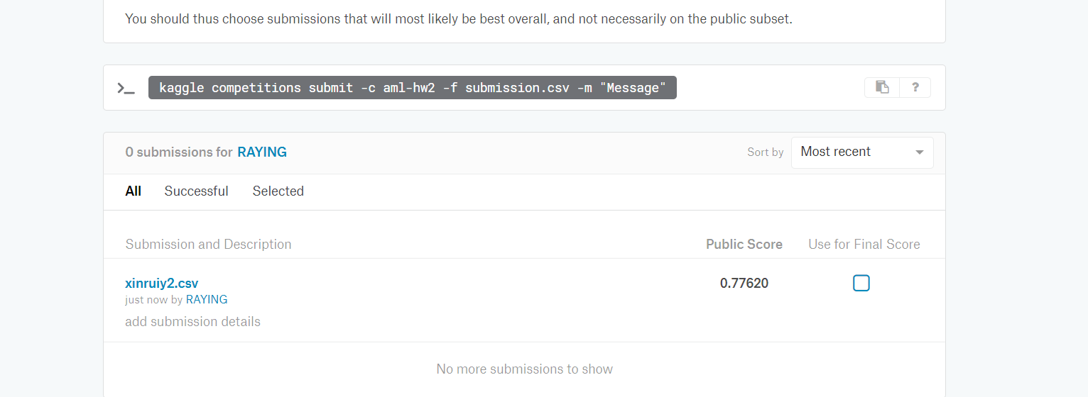

Red line: lambda = 0.001

Blue line: lambda = 0.01

Black line: lambda = 0.1

Yellow line: lambda = 1

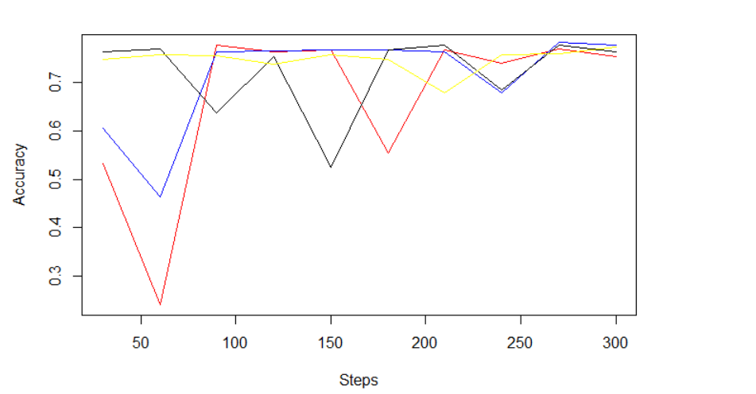

Red line: lambda = 0.001

Blue line: lambda = 0.01

Black line: lambda = 0.1

Yellow line: lambda = 1

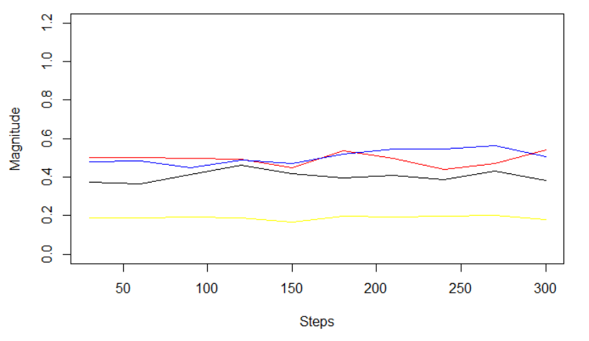

I choose lambda = 0.01, and the learning rate I choose for is the after 300th step using lambda = 0.01. It seems that I have better accuracy over lambda = 0.01 in general. When I test on the validation set, the 300th step for lambda = 0.01 have the best accuracy. The truth is after all 300th steps, the accuracy is all pretty convincing to me.

